Growing Forward

Introduction to the Parish Cultivation Mapping Tool
“A farmer went out to sow his seed. As he was scattering the seed, some fell along the path…” The metaphor of farming has been applied to the mission of the church for Millennia. Every Church was planted at one time and as a result Guildford Diocese with its many parishes is geographically close to all who live within its borders. However, culturally there remains a growing gap, as a large proportion of the population does not engage with inherited forms of church today. This situation calls for a tool that will help with identifying the ‘unploughed ground’ of unreached communities and with engaging in a parish system cultivated for mission, offering pathways for every person into an accessible and contextual expression of church.
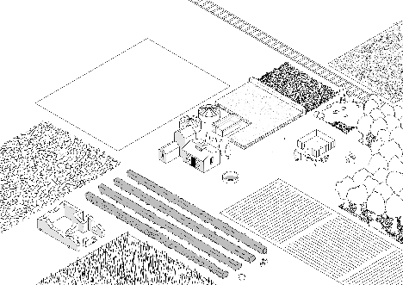
The parish cultivation mapping tool is a playful instrument that will engage those who use it in holistic mission planning. Employing the image of a farm, the parish consists of manifold fields that need utilising. The parish church is symbolised by the farmhouse, a space for family life and a hub of farm related activity with its workshops and barns. This metaphor connects the client with the importance of the context, of diversification, and of regeneration.
How it works:
- This tool works best in a group setting of 4-20 people. As people gather around it is important to reflect together on the metaphor of the ‘parish as a farm’, and on the necessity for a mixed ecology of church including some examples of parishes that have developed this well.
- Take a Flip Chart paper and prepare to stick an A3 copy of the Parish Cultivation Map. Before the picture is positioned, discuss with the group where they see their church building (Farmhouse) in relation to the Parish as a whole. Is it at the centre or the edge of the parish? Once you have established the position of the Farmhouse, stick it on the Flip Chart paper and begin to engage in conversation of what your ‘Farm’ looks like and what needs to be done to bring in the harvest.
- Discovering what you have. Take time with the group to discover what their ‘Farm’ looks like by asking questions like:
- Where does your congregation spend most of their time when their engage with your Parish – on the fields or in the Farmhouse?
- Where would each person place themselves in relation to their engagement with the parish?
- What harvest do you specialise in?
- What fields are you working on?
- Do you have a nursery on your ‘farm’ (e.g., a school or a messy church)?
- Any overgrown woodland or an area that needs rewilding (maybe you discover that a fresh expression of worship might need to be established or a pioneer ministry set up to reach an unchurched group in your parish).
- Are there any disused or unsuitable buildings or undefined fields on the margins of your ‘farm’?
- Are there barriers like a trainline that run through your ‘farm’ that need special consideration?
- Encourage the participants to draw things on the map that they have identified as significant parts of their ‘farm’. What else have they discovered that needs to be put on the map?
- It may be advisable to include some census data of the parish and look at some of the historical and demographic developments that have taken place over the last few years, or decades.
- Spend some time reflecting in prayer as you are contemplating the evolving map.
- Discern how God may lead you in the next phase of developing your patch, your ‘farm’.
- Can you begin to formulate three next steps you may wish to take to develop your ‘farm’?

It would be helpful to have the current/former CDP and Vision statements to hand as you facilitate the conversation. It is important to allow enough time for this process. There is always the temptation to rush a development plan like this. However, the quality of the outcome is likely to increase if the right amount of time is given.
The tool can also help to reflect on the journey taken this far, leading to celebration and thanksgiving. It is commendable to finish the exercise by pointing to things that have borne fruit over the years and by introducing next steps in developing a CDP that will incorporate the findings identified by the Parish Cultivation Map. As the CDP is further developed, we do well in reminding ourselves of the three themes of TCTL: Growing Disciples, Growing Diversity, and Growing Community.
For more information on the Parish Cultivation Map Tool please contact jens.mankel@cofeguildford.org.uk

©2021 Conceptual Design: Jens Mankel
Art work: Jowan Mankel

See also GS 2223 GENERAL SYNOD, Simpler, Humbler, Bolder: A Church for the whole nation which is Christ centred and shaped by the Five Marks of Mission

